SRS DOCUMENT

PROJECT: FOOD DELIVERY WEBSITE (FEAST FUSION)

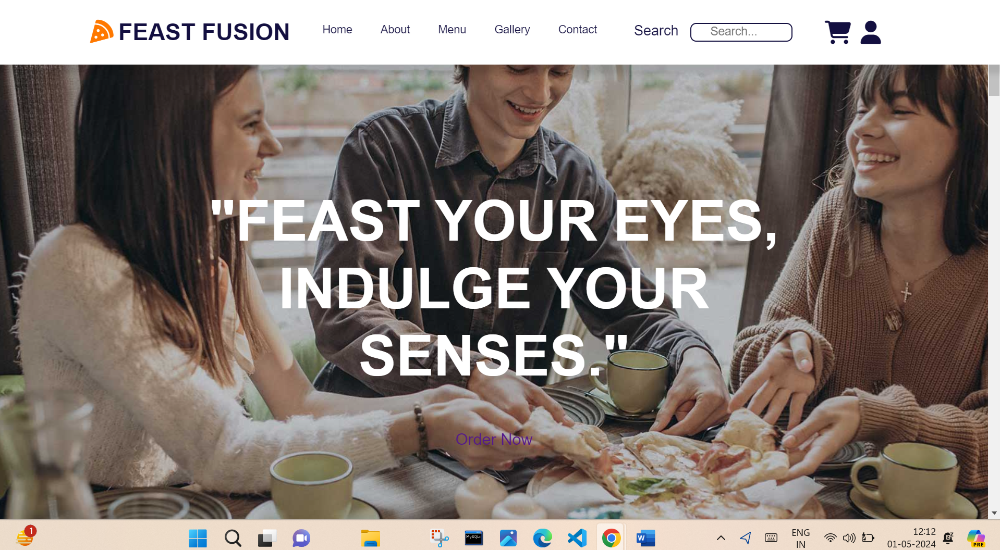

SUBMITTED BY: SHAILAV JUSTA

SAP ID: 500107420

ROLL NO: R2142220638

BATCH: 09 (AIML)

PURPOSE:

The purpose of a food delivery website is to provide a platform where users can browse menus, place orders, and have food delivered to their desired location. These websites offer convenience by allowing customers to order food from a variety of restaurants without leaving their home or office. They typically include features such as search functionality, user reviews, payment options, order tracking, and customer support. Food delivery websites also benefit restaurants by expanding their customer reach and providing an additional revenue stream. Overall, the purpose is to facilitate the process of ordering food for both customers and restaurants.

Top of Form

SCOPE:

Customers will be able to view products, place orders, and make payments online through the website.

FEATURES:

User authentication: Users are able to create accounts, log in, and access their information.

Product Catalog: List baked goods together with their names, descriptions, prices, and pictures.

Shopping Cart: Customers can browse the contents of their cart, add or delete things, and check out.

Order Management: Users are able to check information, status, and order history.

Admin Dashboard: Listing products, viewing orders, and managing user accounts are all available to administrators.

TECHNOLOGY :

* Html
* Css
* Javascript (JS)
* Angular JS

SCREENSHOTS OF THE WEBSITE:

The home page of the website, which includes a “Login/Signup” button, all the links to other pages



The “Login/Signup” button logs in or signs up the user

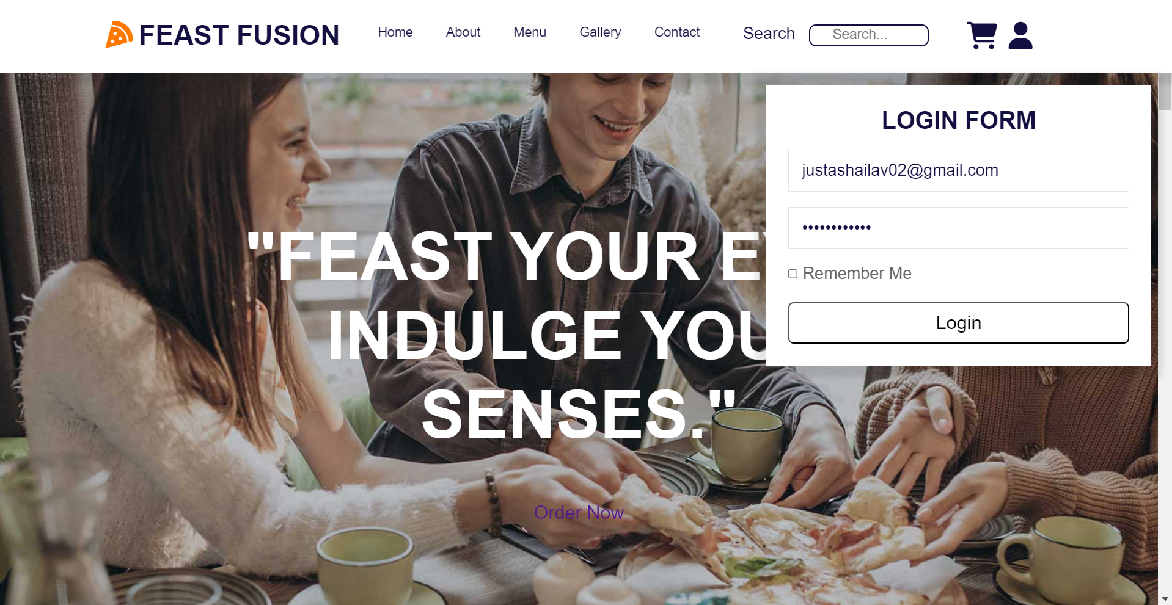

SHOPPING CART:

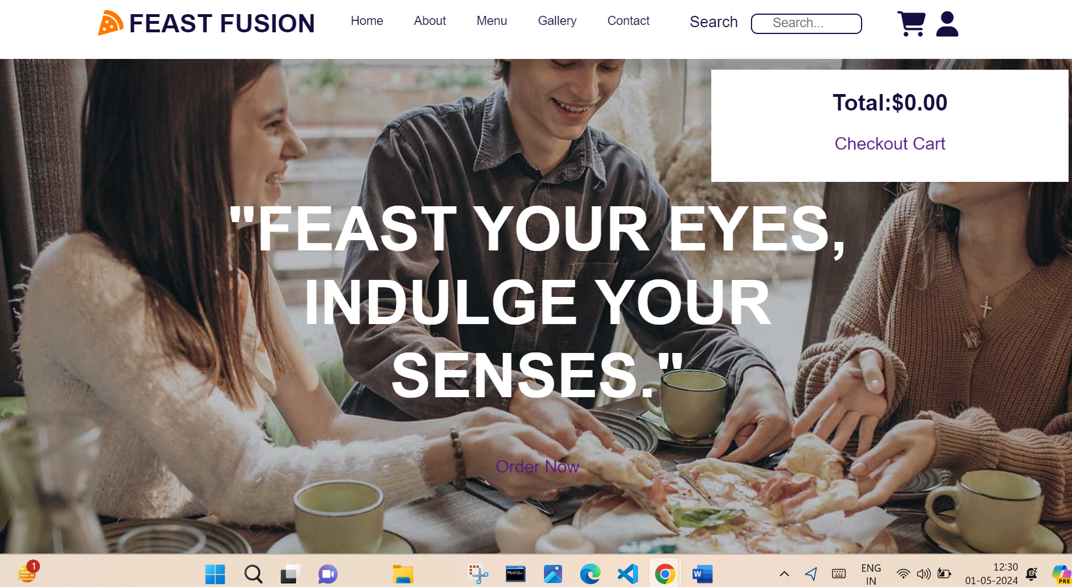

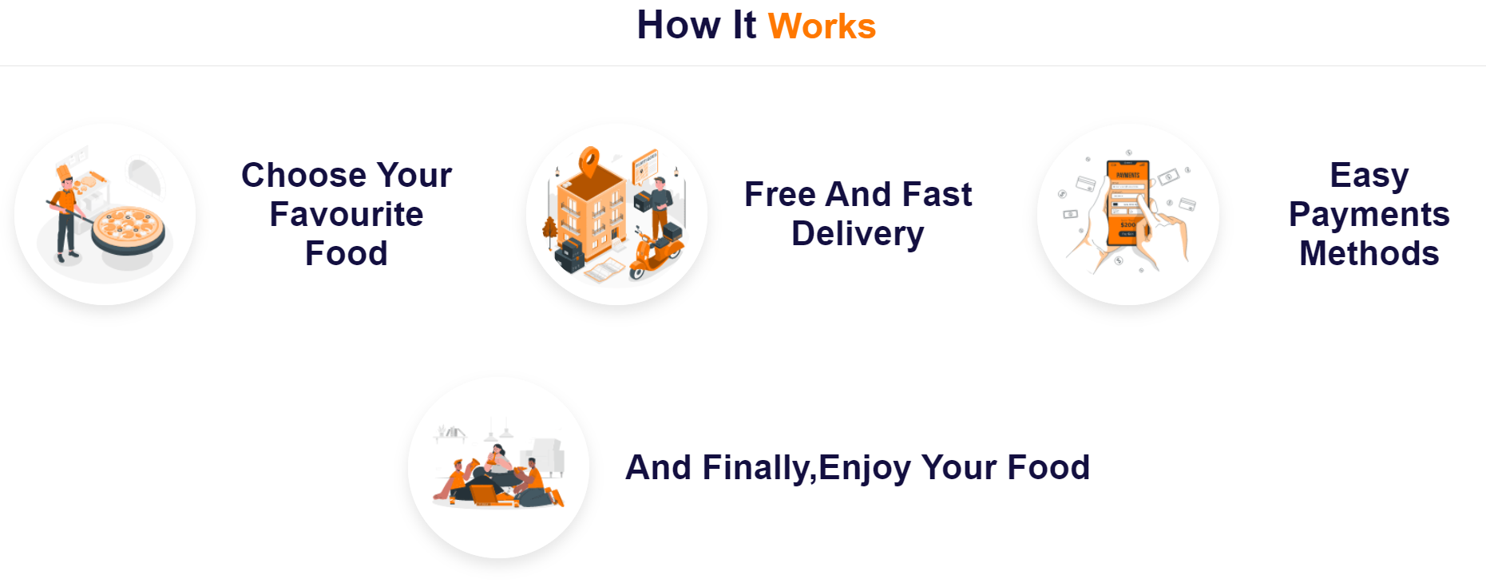

Few of the item’s description

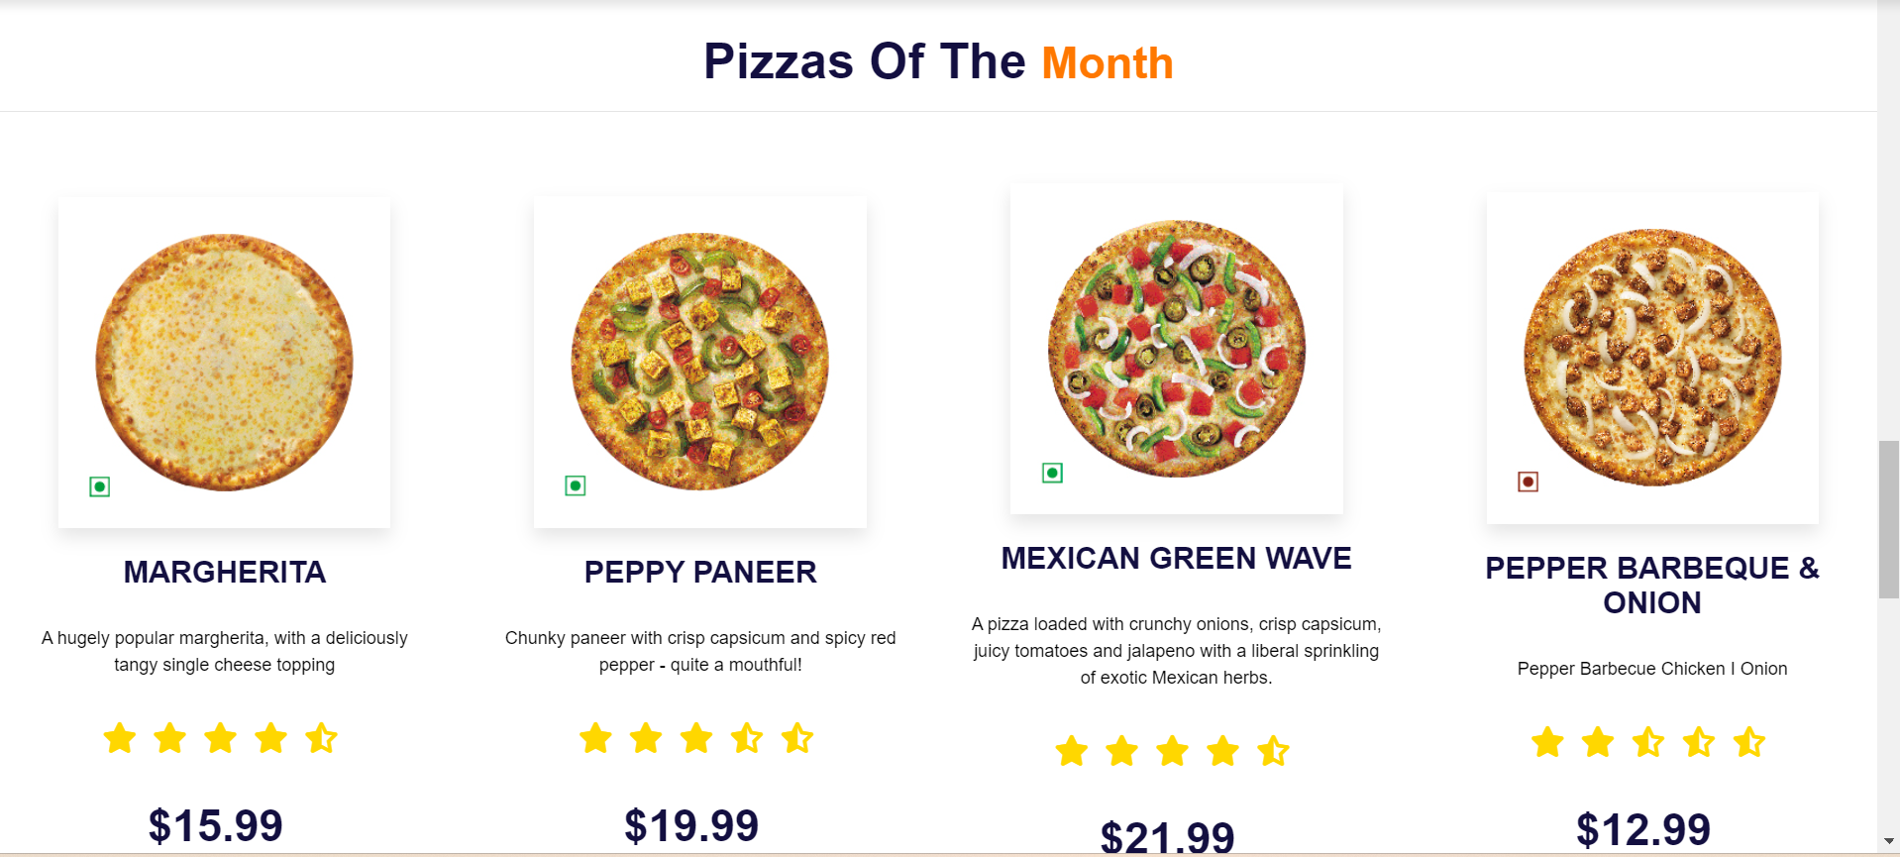

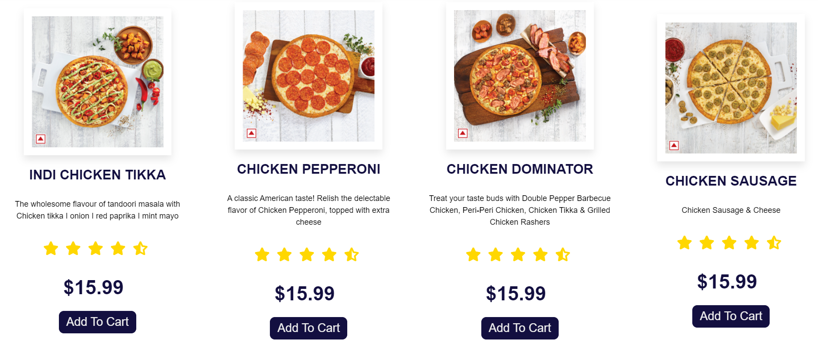



About Page

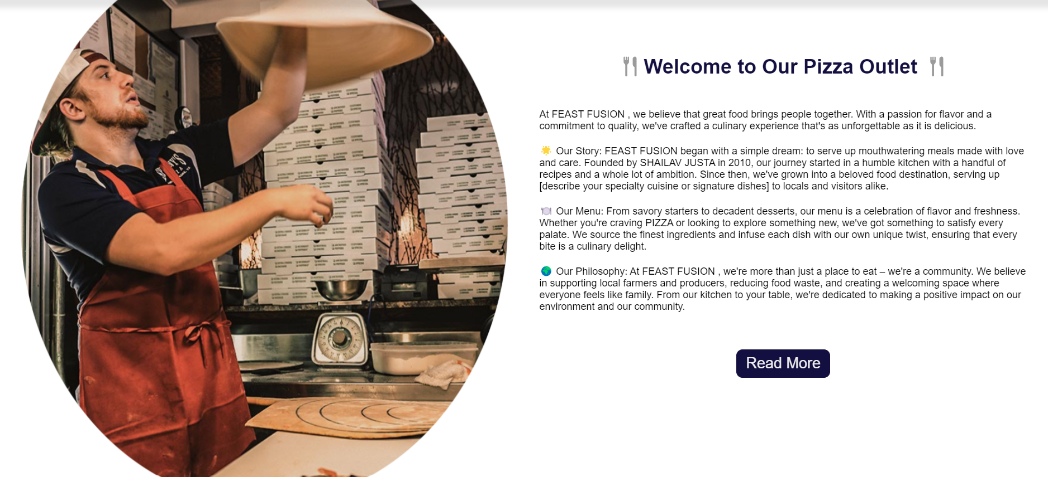

READ MORE

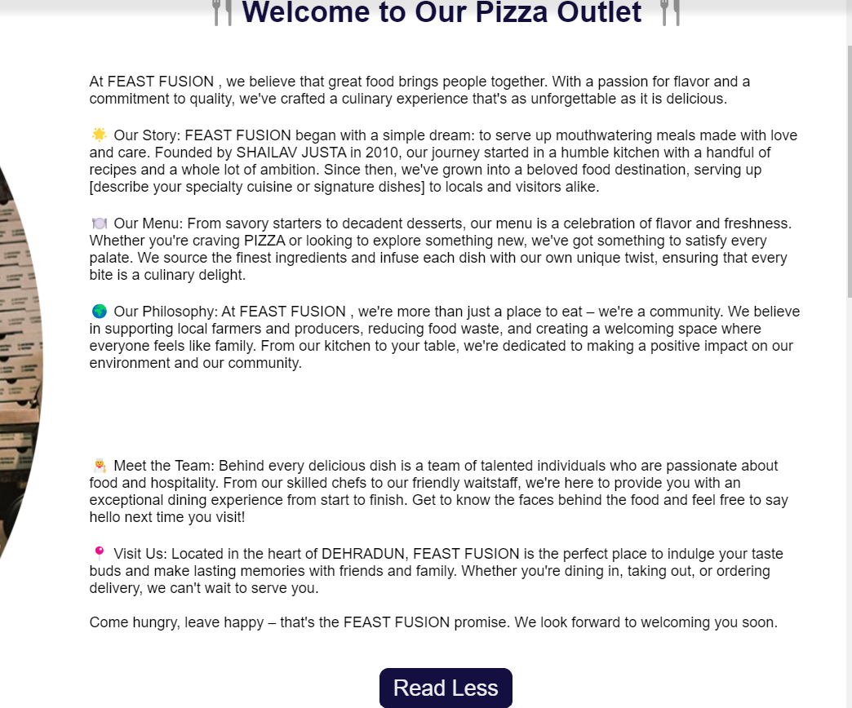

Gallery view

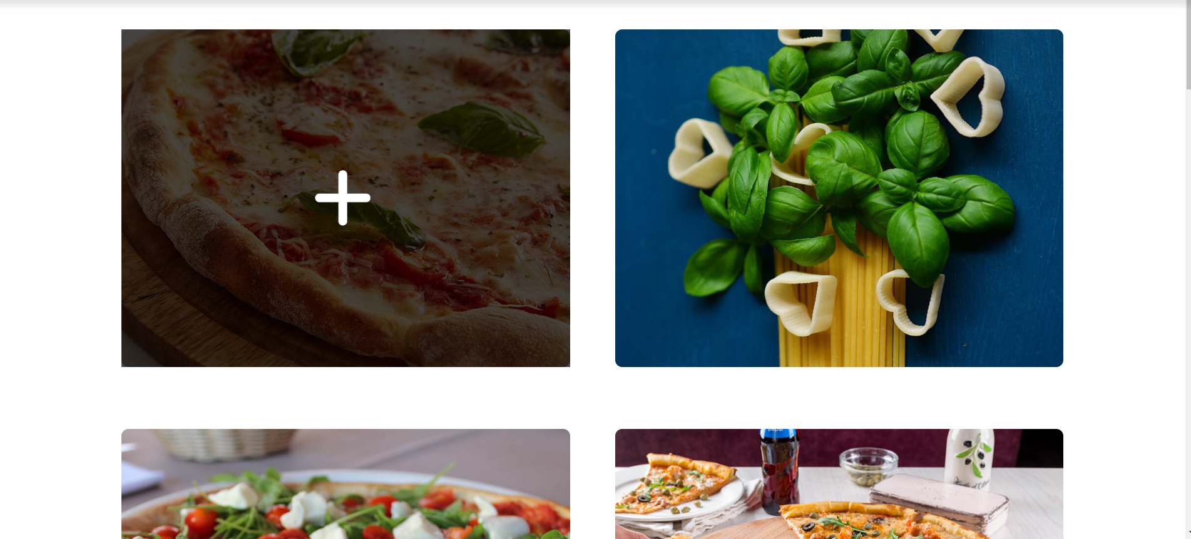

Contact page

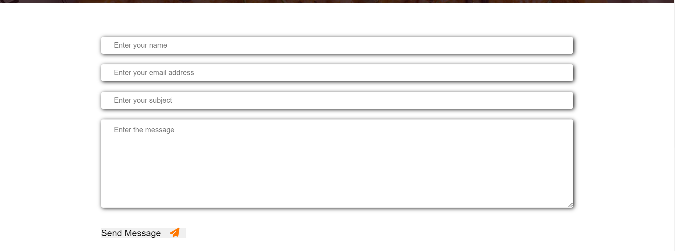

FUNCTIONAL REQUIREMENTS:

Functional requirements describe the specific features and functionalities of the website. These include:

* Login from
* Contact details
* Product
* Gallery
* Shopping Cart

NON-FUNCTIONAL REQUIREMENTS:

Non-functional requirements define the qualities or attributes of the websites. These include:

* Performance
* Scalability
* Reliability
* Usability

